PHASE 3
Project Design
System Architecture Diagram
The AI StudyBuddy API follows the MVC (Model-View-Controller) pattern to decouple business logic from data management. The Controller layer orchestrates study topic management and the generation of AI study aids via Gemini, while the Model layer manages User and Topic entities.
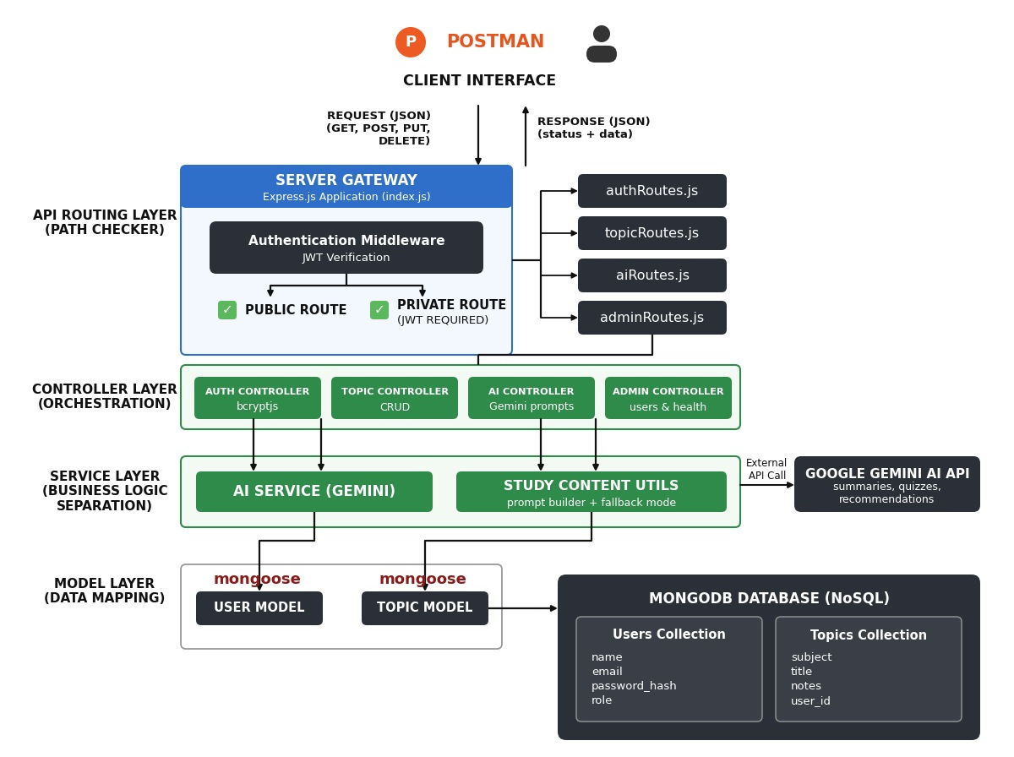
Fig 3.1 – Technical Architecture Diagram of the AI StudyBuddy API (MVC structure)

MVC Architecture Pattern
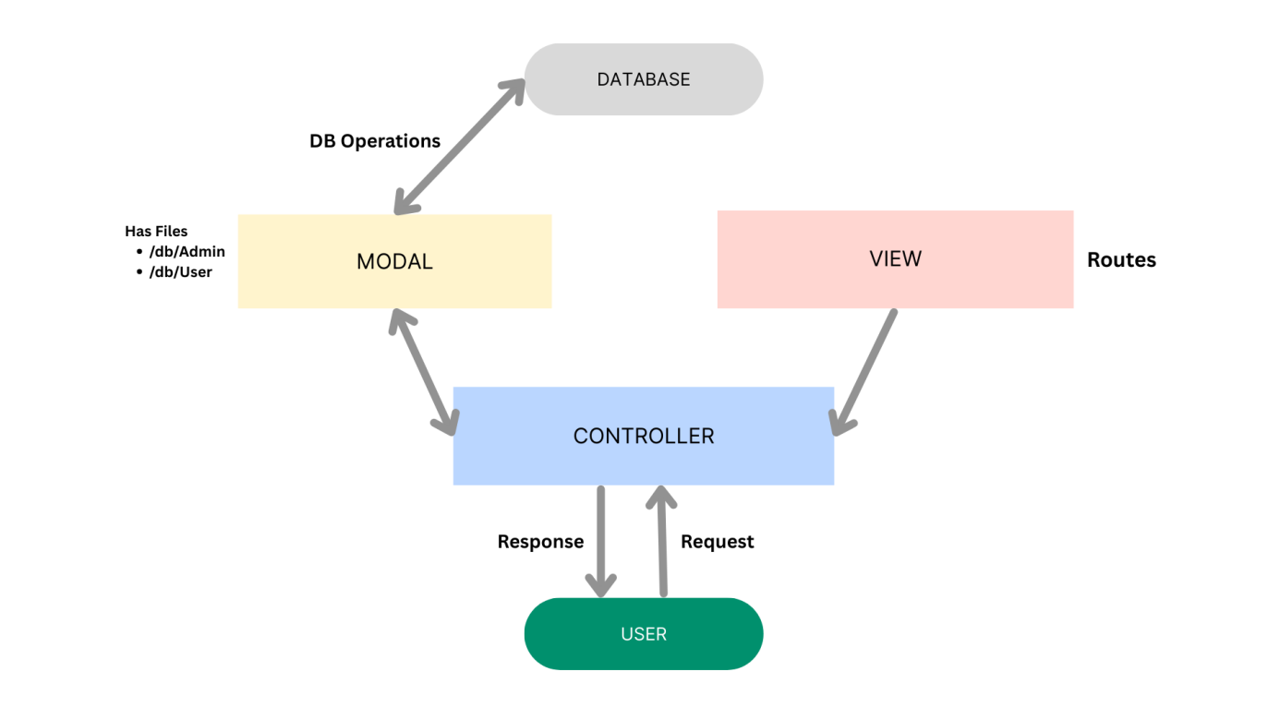
Fig 3.2 – Model-View-Controller architecture pattern used in the backend
Model Layer: Defines structure blueprints via strongly enforced Mongoose schemas mapping explicit fields into raw collection items inside MongoDB.
Controller Layer: Captures request vectors from the routes, checks structural request constraints, delegates processing to models, and packages the resultant output into JSON responses.
View Layer: As a headless backend service, the interface layer lives as an API Routing Layer, linking network requests on specified paths directly to their controller handlers.

Flowchart
The following flowchart illustrates the sequential user flow through the AI StudyBuddy API, from authentication to receiving AI-driven study aids.
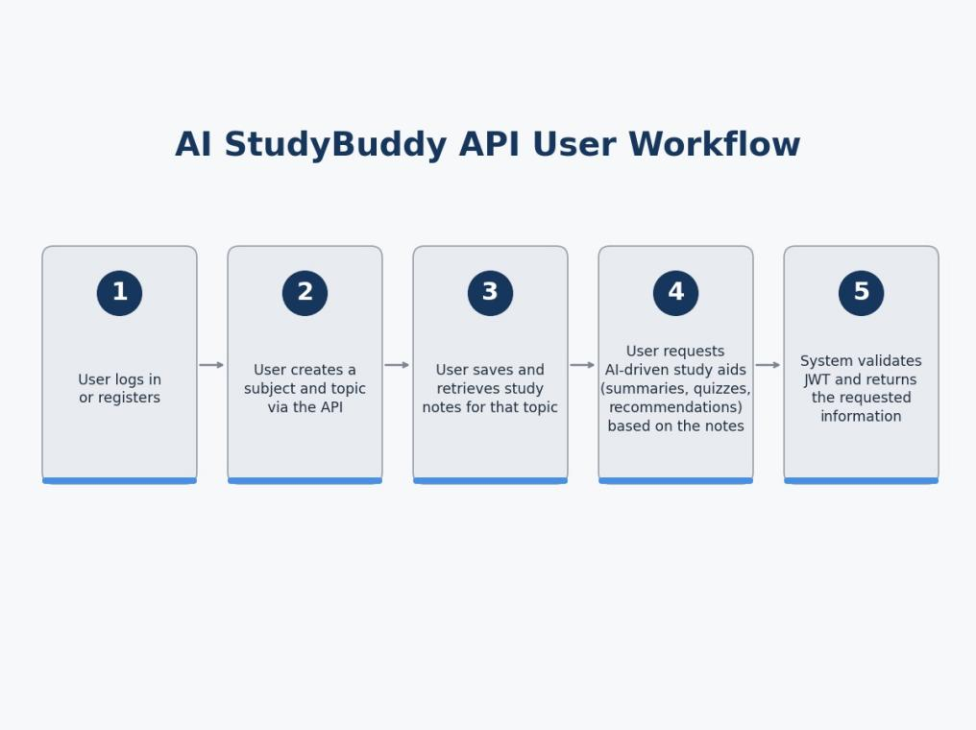
Fig 3.3 – User flow flowchart for the AI StudyBuddy API
ER Diagram / Database Design
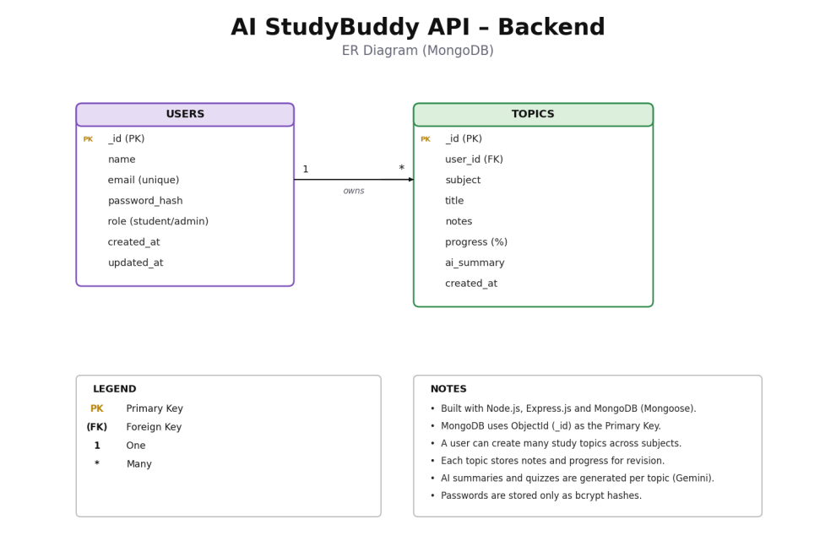
Fig 3.4 – Entity-Relationship diagram of User and Topic collections
User Entity
- _id – Primary Key (ObjectId)
- name – String, Required
- email – String, Required, Unique
- password – String, Hashed, Required
- role – String, Default: "student"
Topic Entity
- _id – Primary Key (ObjectId)
- user – Foreign Key referencing User collection
- subject – String, Required
- title – String, Required
- notes – String
- progress – Number, Default: 0
- ai_summary – String, Optional
- createdAt – Date, Default: Now
Key Structural Mapping: User to Topic is a One-to-Many relationship – a registered user can create multiple study topics across different subjects.

Module Structure
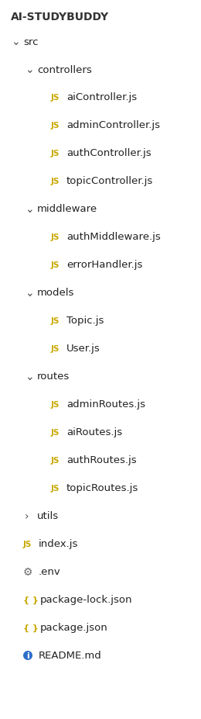
Fig 3.5 – Backend core structure / module implementation

Fig 3.6 – Project folder structure
- Routing Layer – maps HTTP endpoints to controller functions.
- Controller Modules – Auth Controller, Topic Controller, AI Insight Controller, Admin Controller.
- Middleware – Authentication & Role Matrix Middleware, sanitization, centralized error handler.
- Model Layer – User schema and Topic schema (Mongoose).
- Service Layer – Gemini AI integration service and study content utilities (prompt builder, fallback mode).

